Stock Addition is the feature in the AGRIS Warehouse app, below I am sharing and adding Development Jira Ticket:
DEscription:
Workflow:

1. Warehouse PRO user logs into the app and is required to select the Vendor ID Range before continuing with a Stock Addition. Message should appear saying that they cannot do a Stock Addition without going to Settings and selecting a Vendor ID Range.

2. The user must first take a photo of the BOL form by either accessing their camera or selecting a list of existing images from their gallery.

3. They can either confirm, delete, or add more photos. Otherwise they can hit continue to move to the next step.
**Photos need to be uploaded to AttachToo with the Voucher as a sub-document. Document Type needs to be discussed.

4. The User will be able to search for the Vendor by either entering Name, Name ID, City, or Phone Number and select from an available list of Vendors.

5. The User can confirm Vendor Selection and hit continue to move on to Item Selection
**Remit To should be based on what is selected for the Vendor automatically but should not be visible to the user

6. User should be able to search for an item using the barcode scanner or by entering in item information to pull a list of relevant items

7. Once an item is selected should take user to a new page that will allow them to enter the qty and view the UOM
**If the item requires a lot number or specification fields like LOT# those should appear below the quantity and be required to enter before continuing.

8. Once User completes the first item they should be taken to an item information page where they can choose to: delete or edit an item they entered; add another item to the stock addition; or continue to the next screen.

9. If required* User will need to enter Transaction Fields which are customizable based on setup in AGRIS and configuration setup in Action List

10. User will be required to enter the BOL # and can choose to enter Voucher Description and Remarks

10. User will be taken to a Summary page where they can review the following: Vendor Information; BOL Photos; Item Information; BOL #; Voucher Description; and Remarks
**User will need to scroll down to the bottom of the page in order to Submit the voucher

11. Once Submitted, User will view a confirmation and Voucher # from AGRIS

ACCEPTANCE CRITERIA:
1. Warehouse Pro users only can access Stock Addition feature
2. User can access a list of vendor names to add Stock Addition information
3. The user can look up the list of items based on Location ID and/or Barcode Scan
4. Barcode scan can return information about the item
5. The user can enter additional item information
6. The user can review the final Voucher information and go back to make changes if need be
7. Once the voucher is submitted in App, it needs to return to Agris as a copy and paste and generate an automatic voucher number

Flow Screenshot:

Navigate to Stock Addition
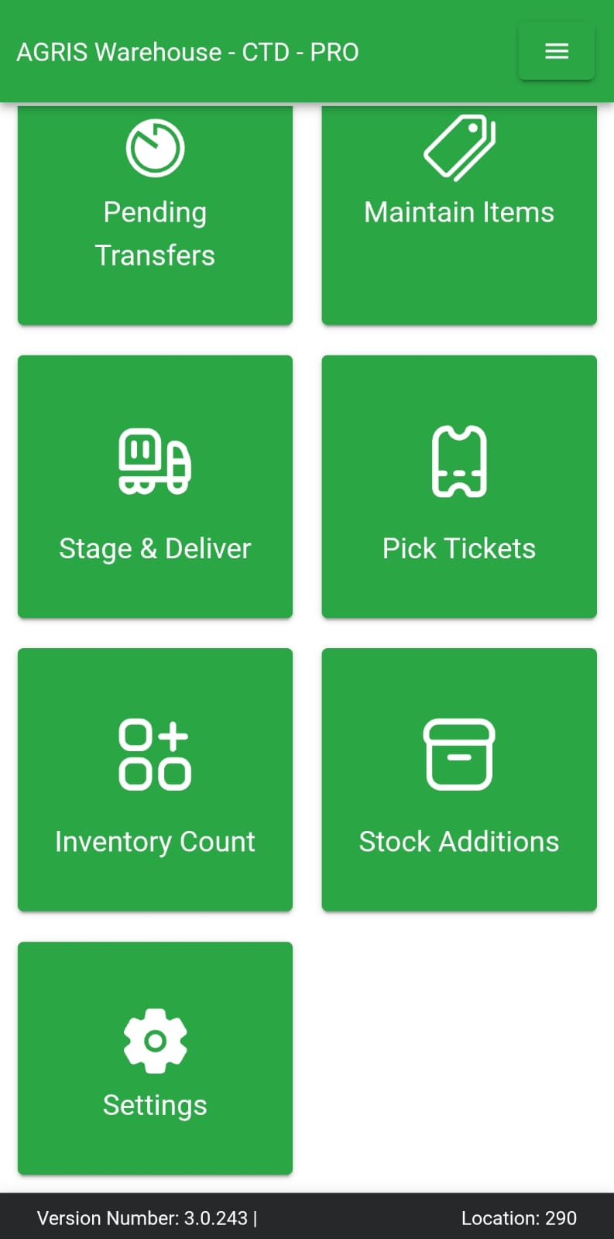
It will ask for selecting vendor name id type range from setting
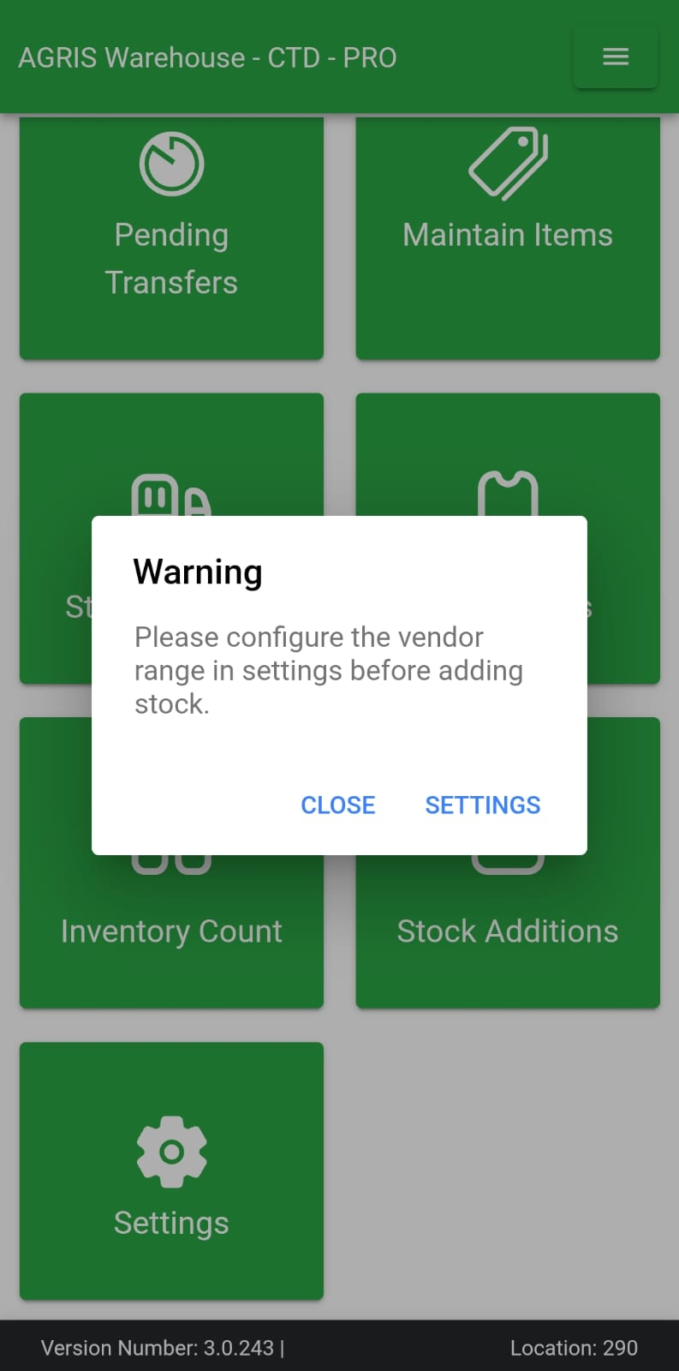
Go to Setting and Select Name ID Type Range
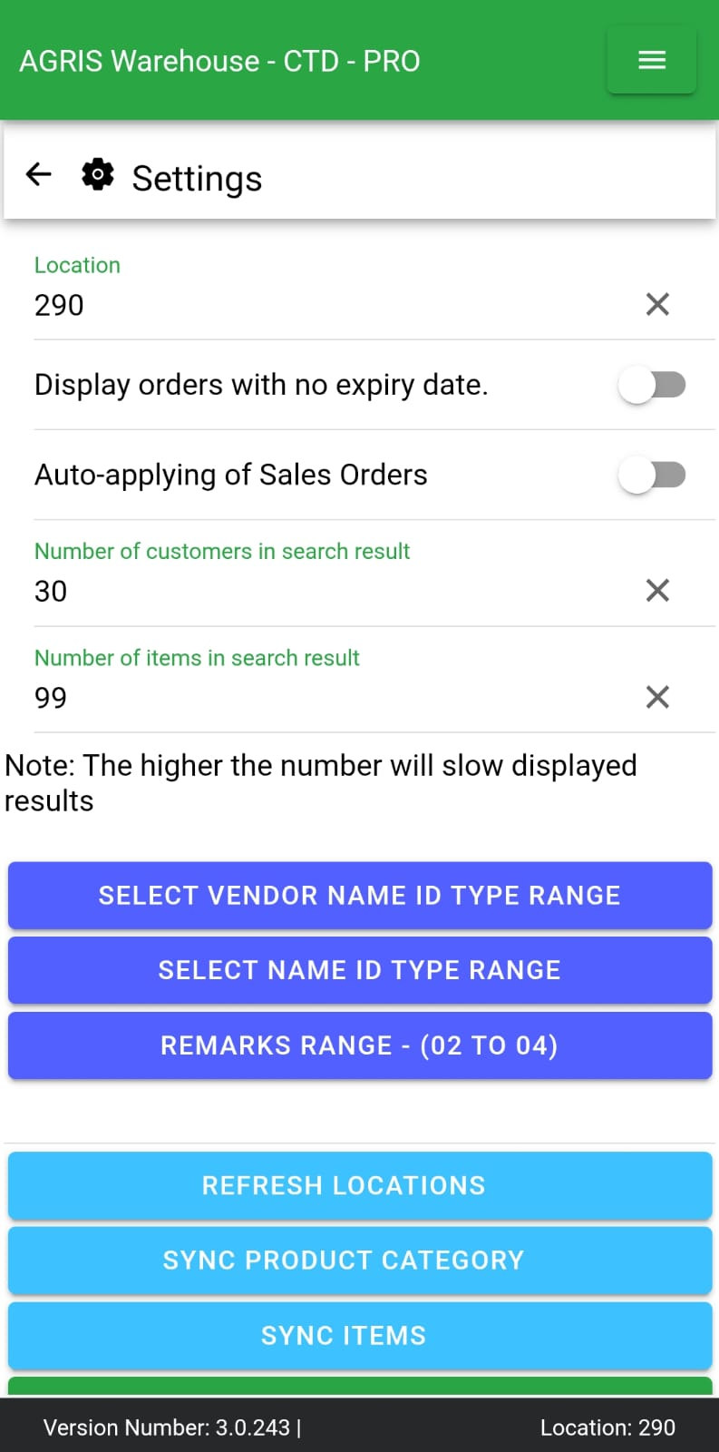
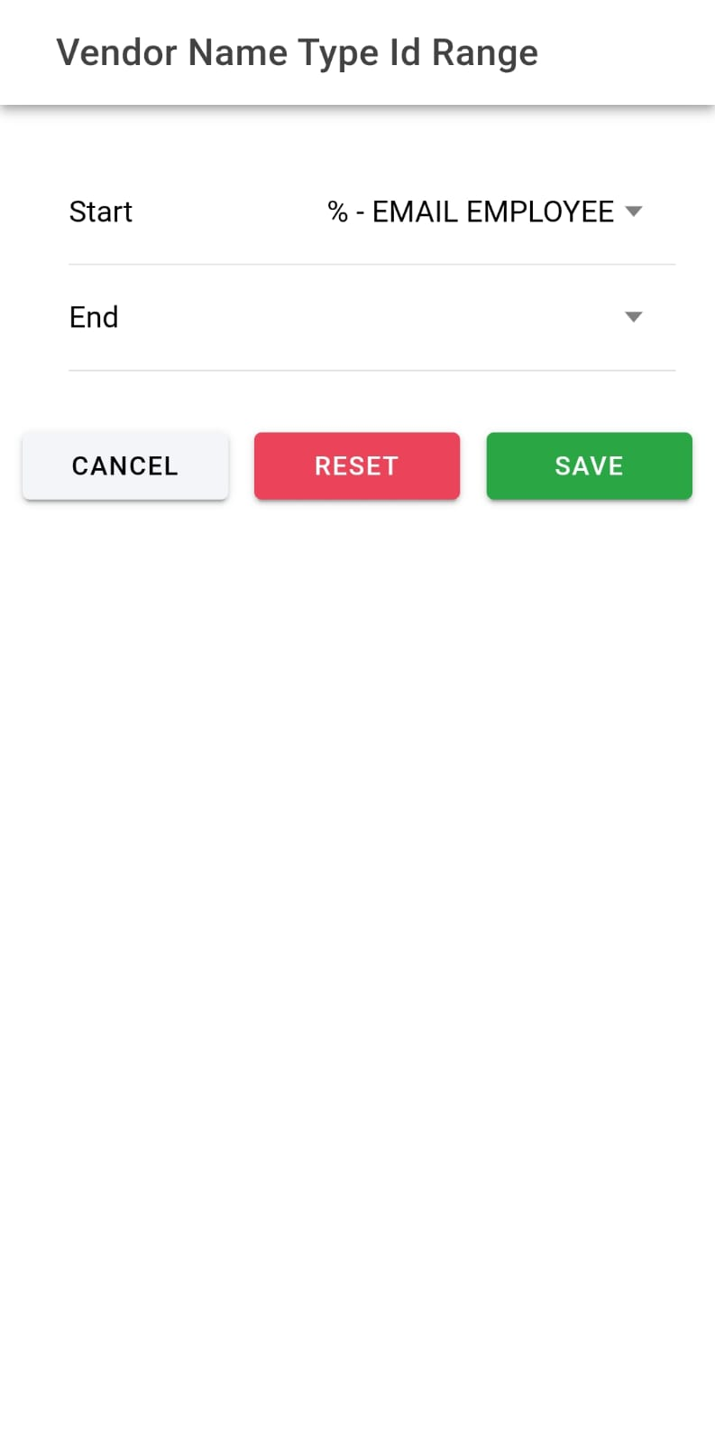
Save Vendor name id type range and save settings as well

Go to Stock Addition Again
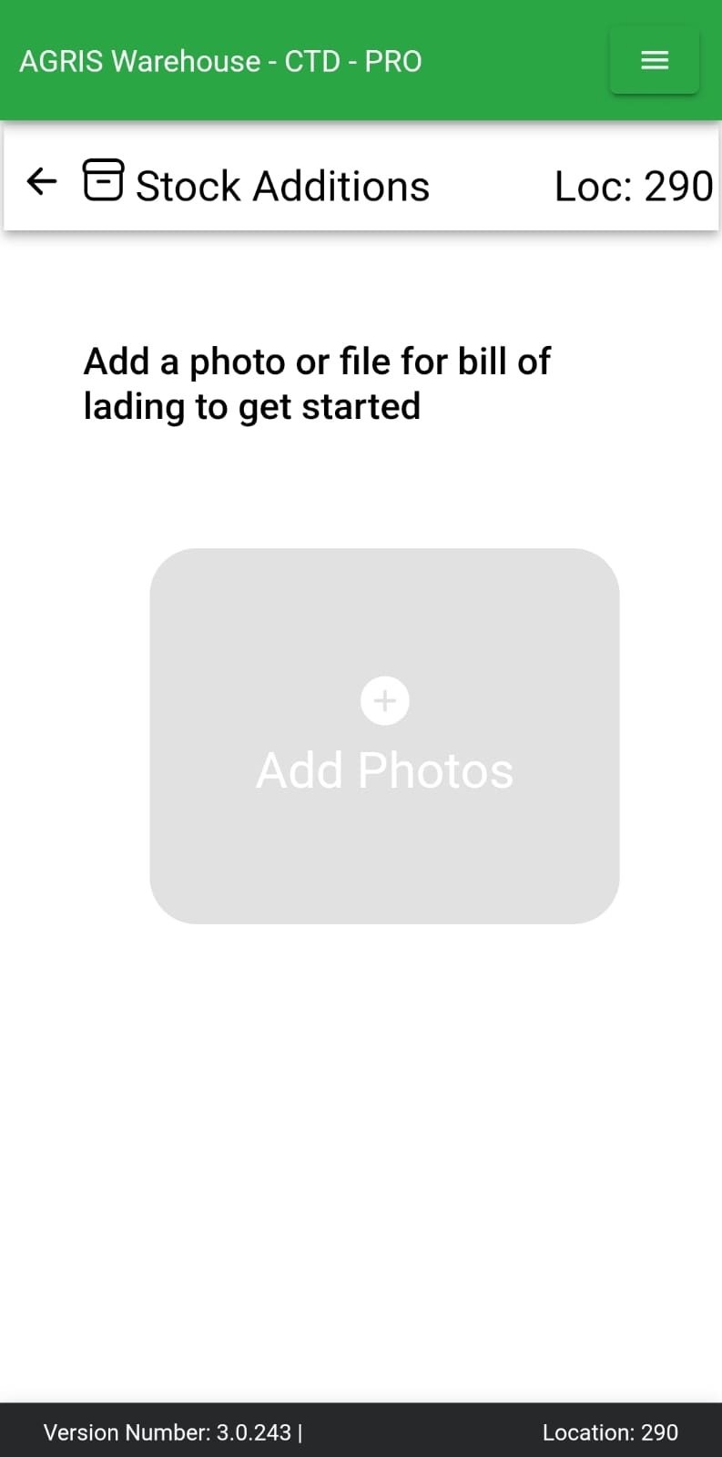
We can Capture and/or add up to 4 images from gallery

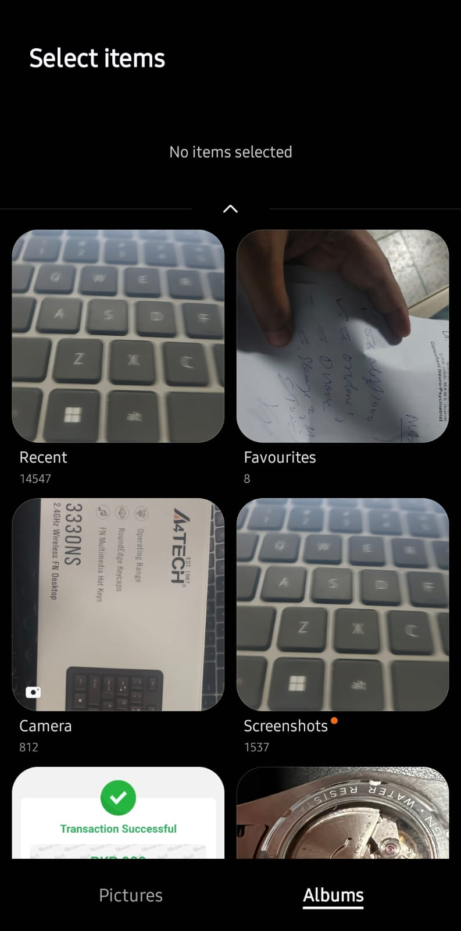
Weather we capture images from camera or we add it from gallery or we opt both together, we cannot exceed total of 4.

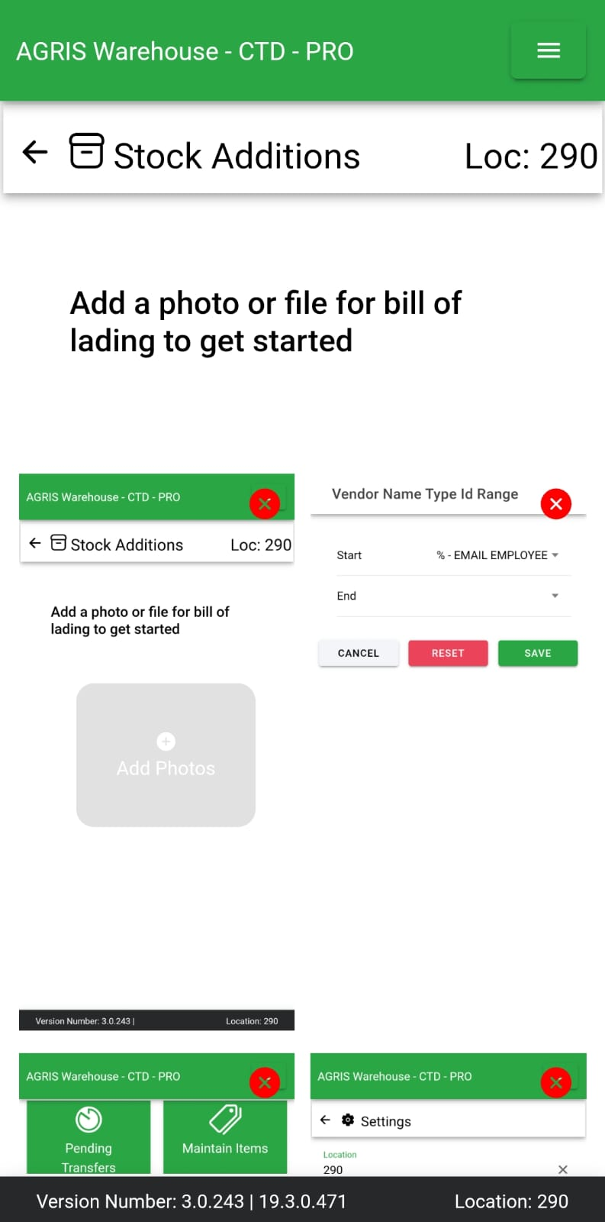
We can delete added pics and add more after deleted as well to fill the count of max 4 images
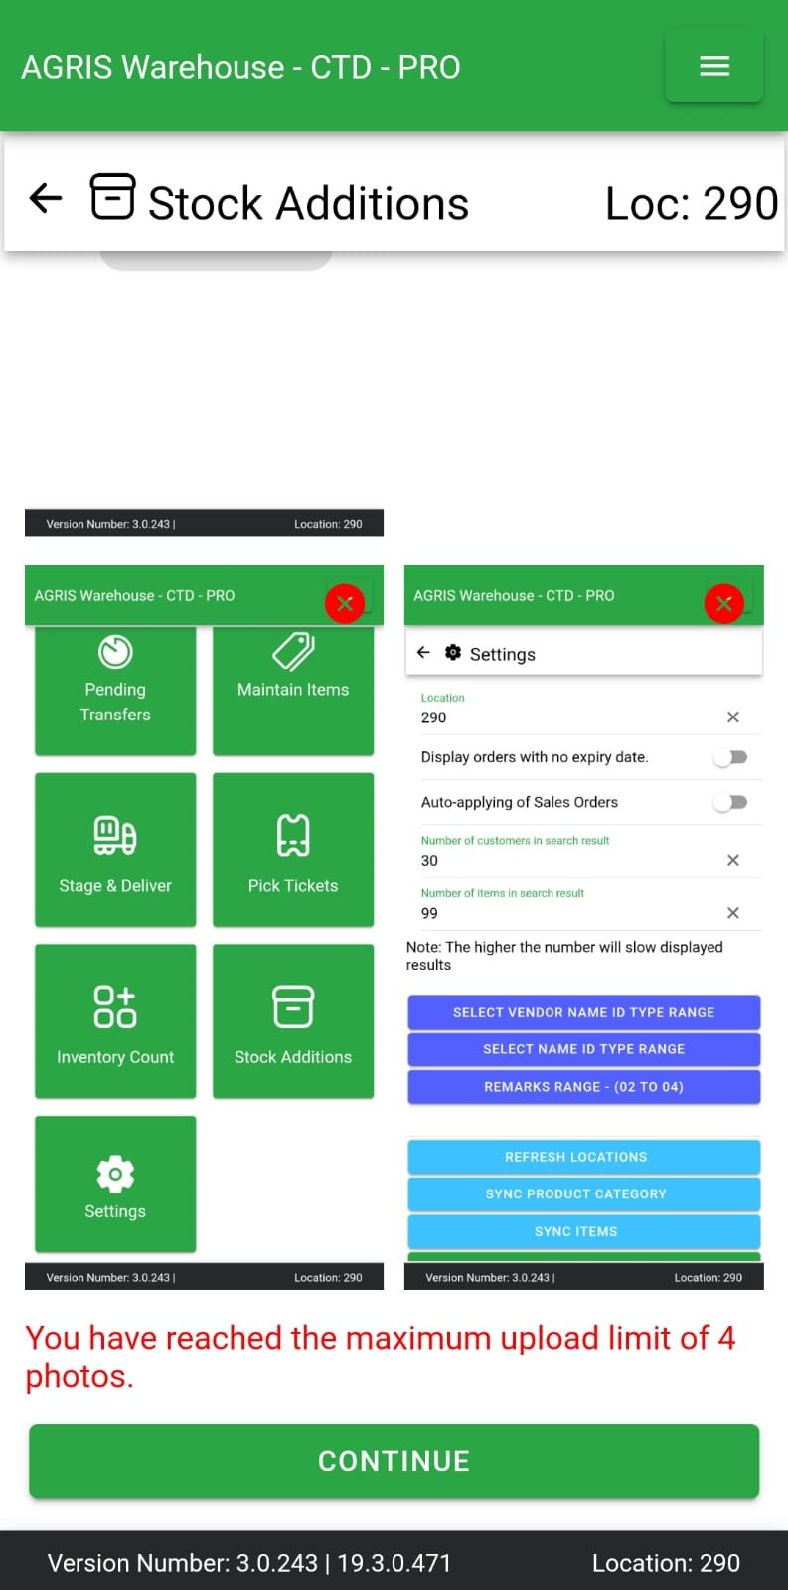
We can scroll down and hit continue
Now we are on the vendor search screen,
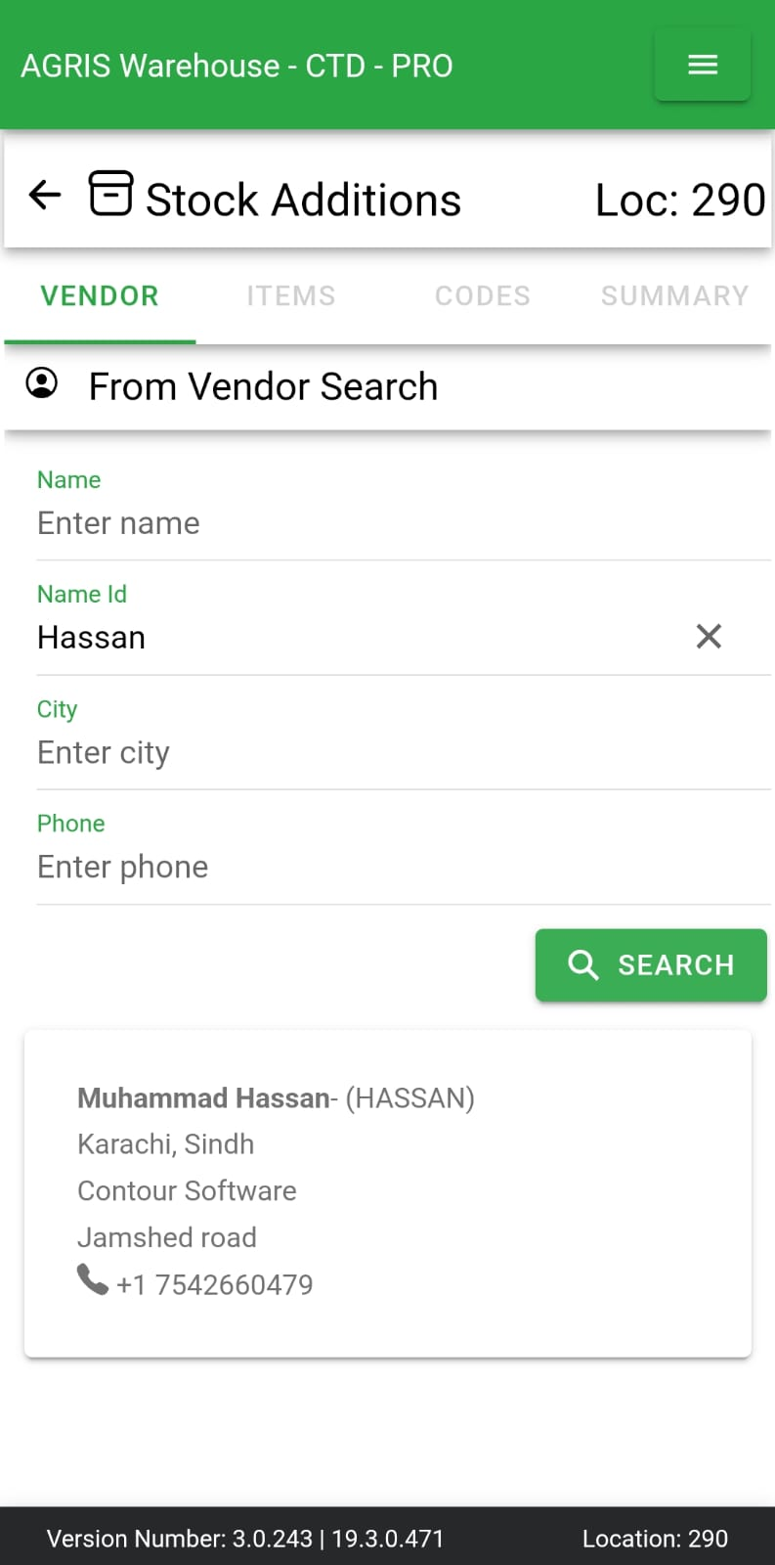
We would be shown list of available vendors as per our search, on selecting vendor it will display as
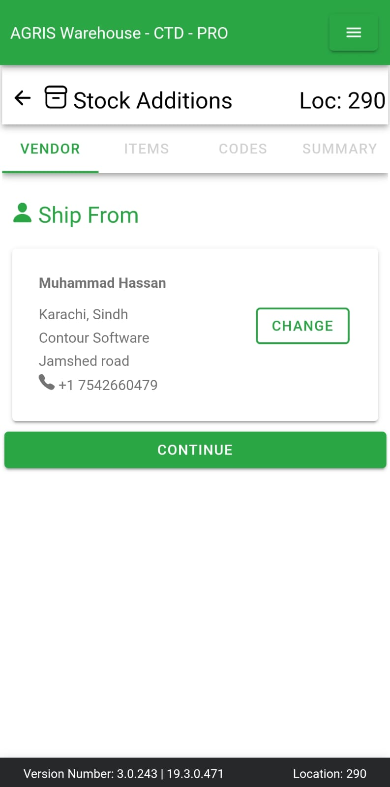
We can change the vendor by clicking change on the selected vendor card, it will move back us to vendor search screen. We can either cancel vendor search and move back with previously selected vendor or we can search and select the new one.
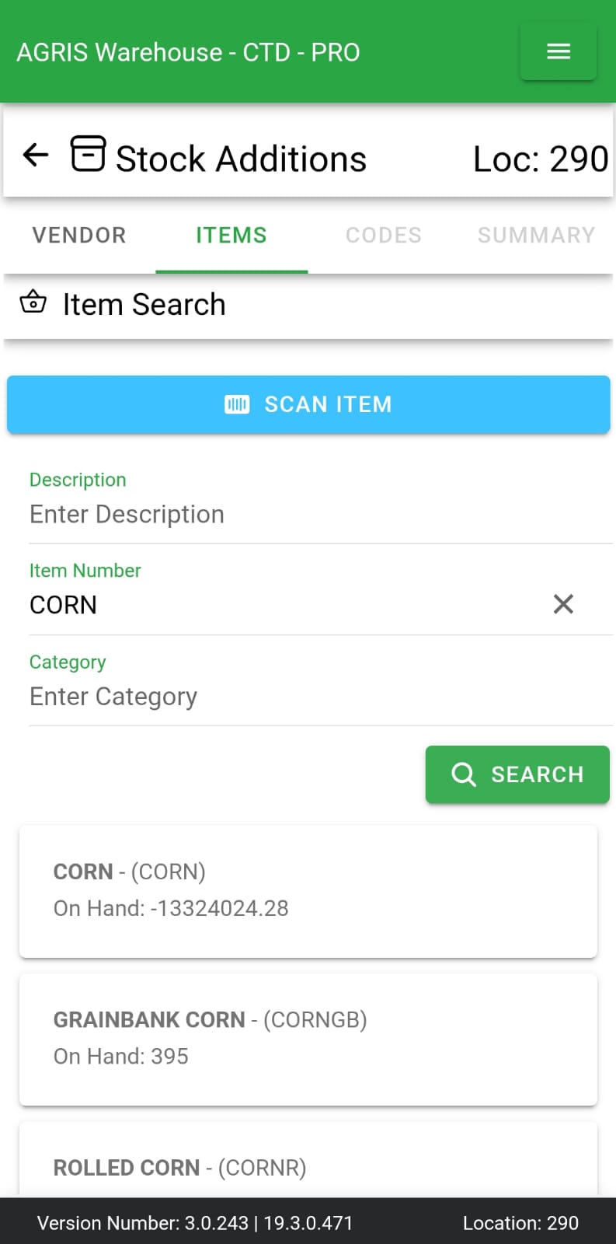
We do have a screen for searching and adding items for stock addition, item can have a lot number or can be just a simple item without lot number. Item can be searched via barcode scan as can be seen in the screenshot with scan item button.
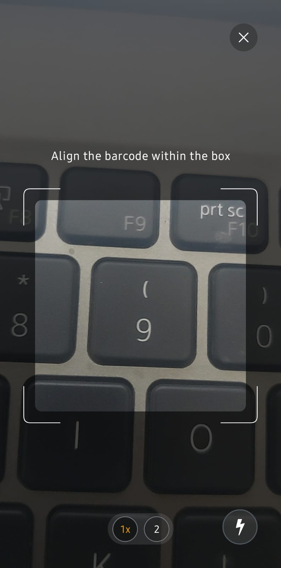
On scanning barcode it will select that item and ask us to add the quantity, same for the searching and selecting manually.
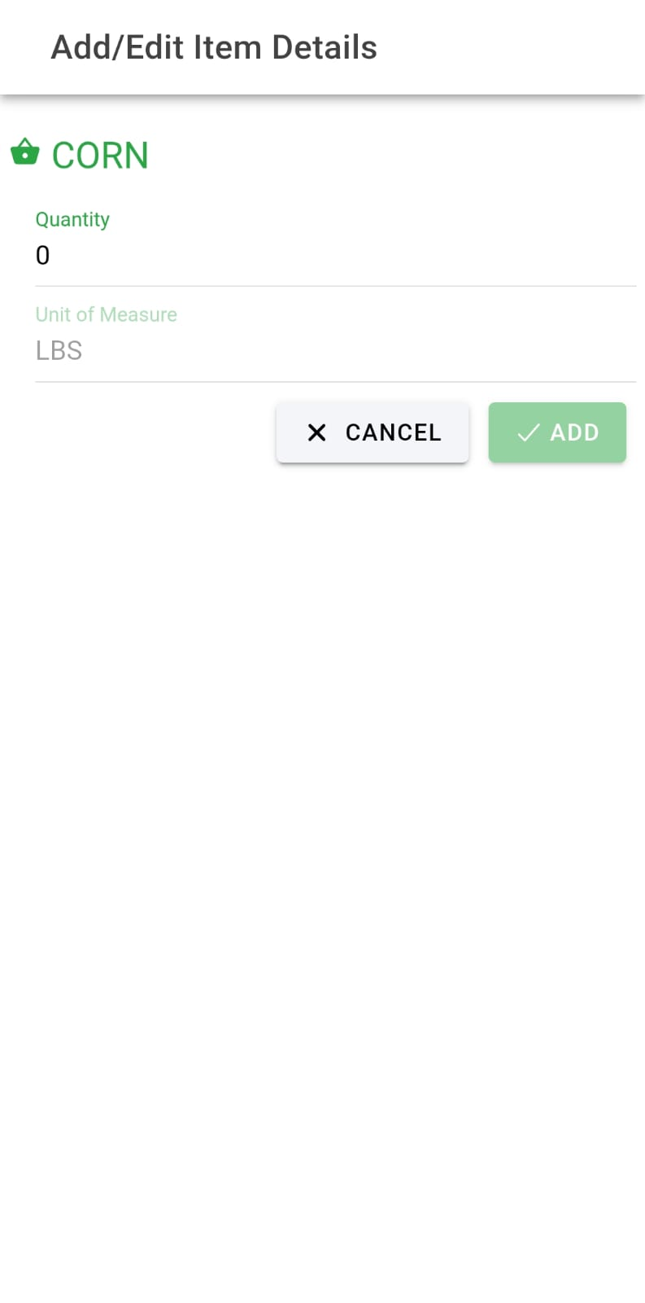

If we select item with lot number it will ask us to either select the existing lot number and proceed or create a new lot number
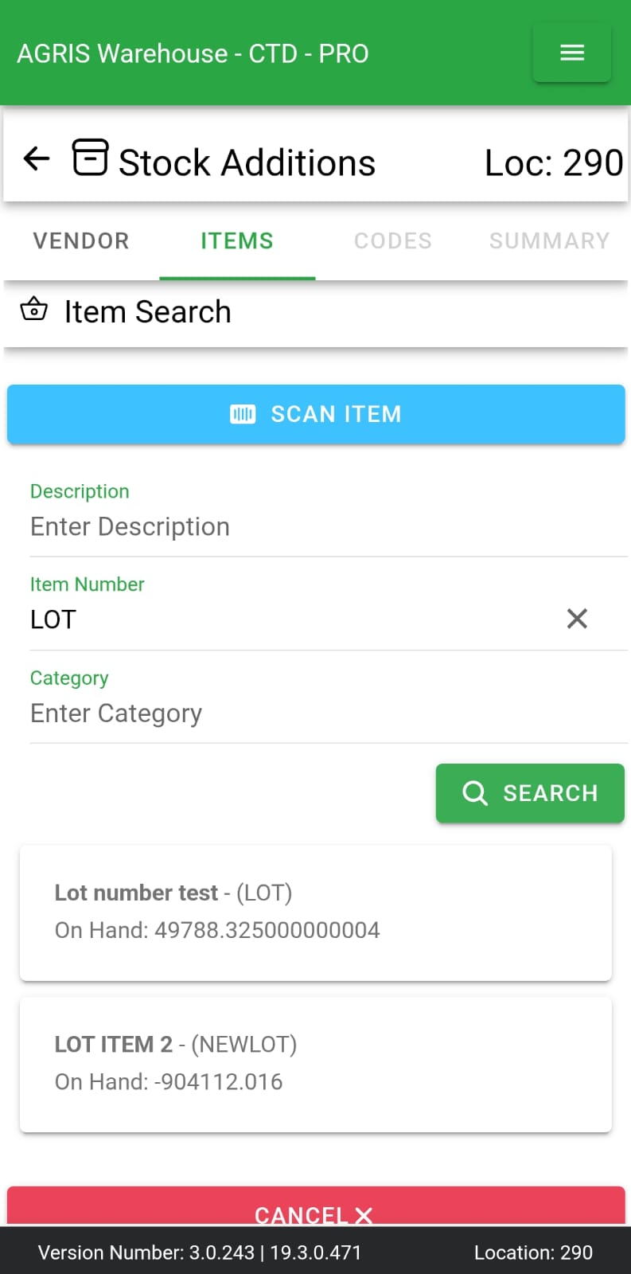
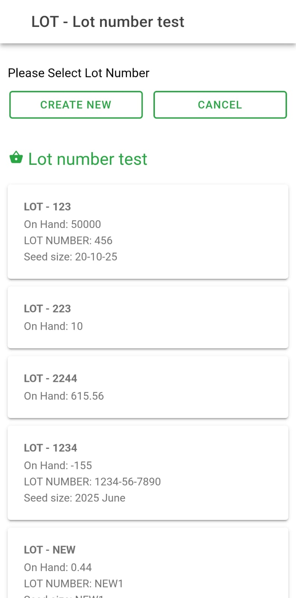
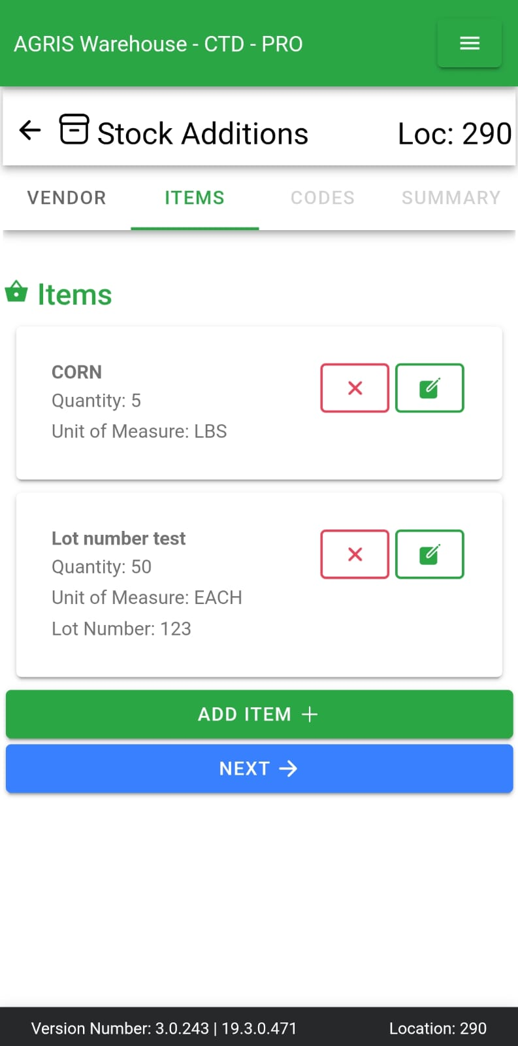
After adding items we are proceeded to Transaction codes tab,
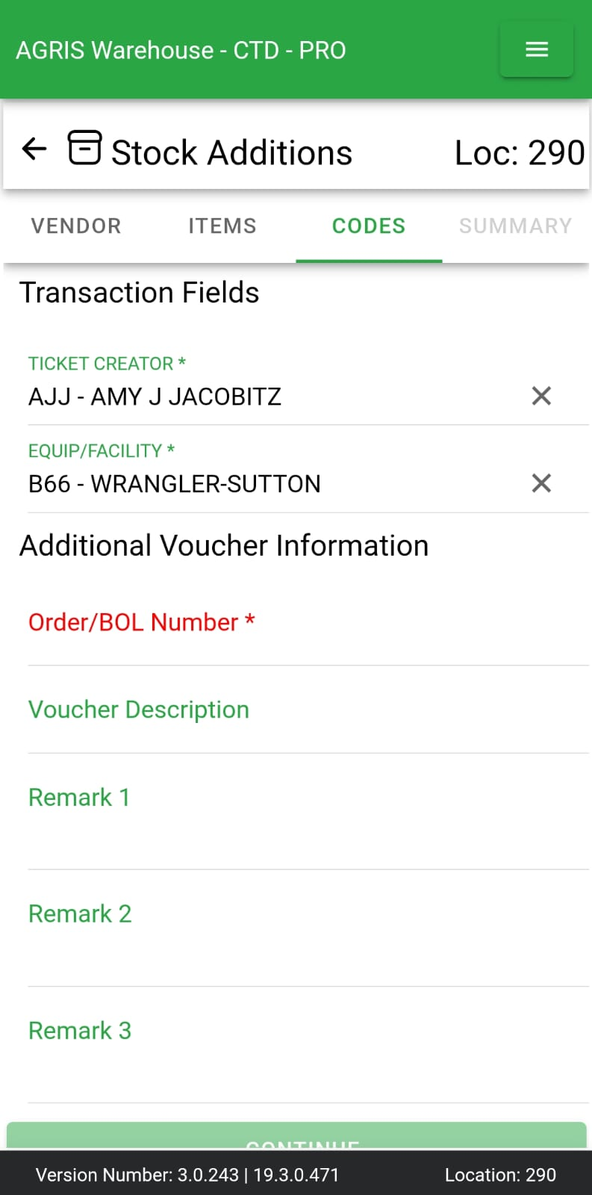

These transaction codes can be added/removed from agris, some of them would be considered required and some might be optional, these are fetched as per the selected vendor from ERP, it can be changed and for the vendors that does not have transaction codes, it can be selected from here, it should not allowed any entry that is not present in the AGRIS (ERP where all data is coming from), whenever anything is typed in this field it will show related available entries as a dropdown
Additional Voucher information, BOL is required rest is optional. Whatever we add here can be seen in the summary

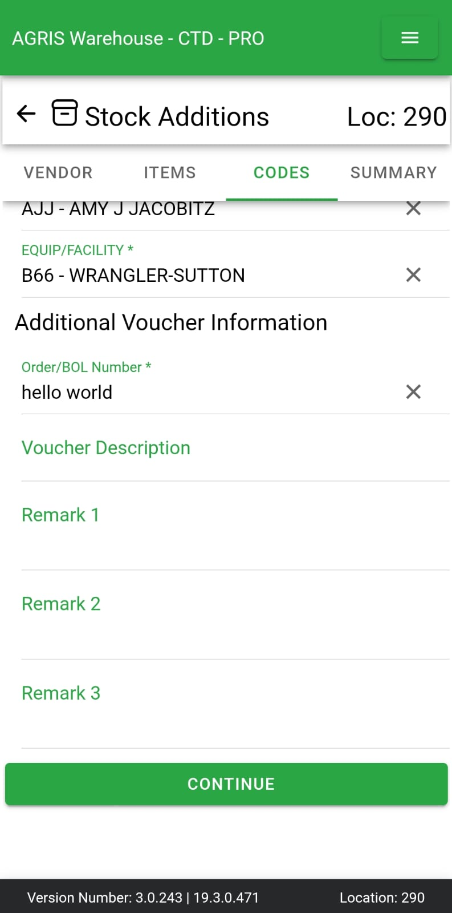
Vendor details, BOL images added initially, items added, additional voucher information is available in the summary
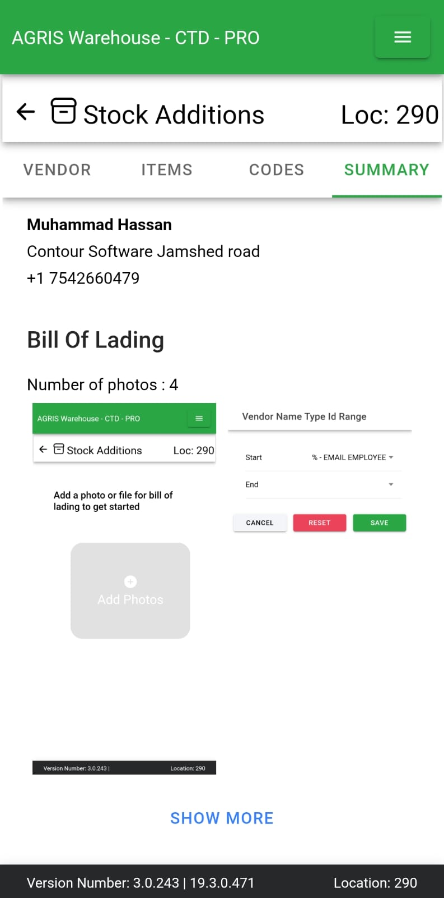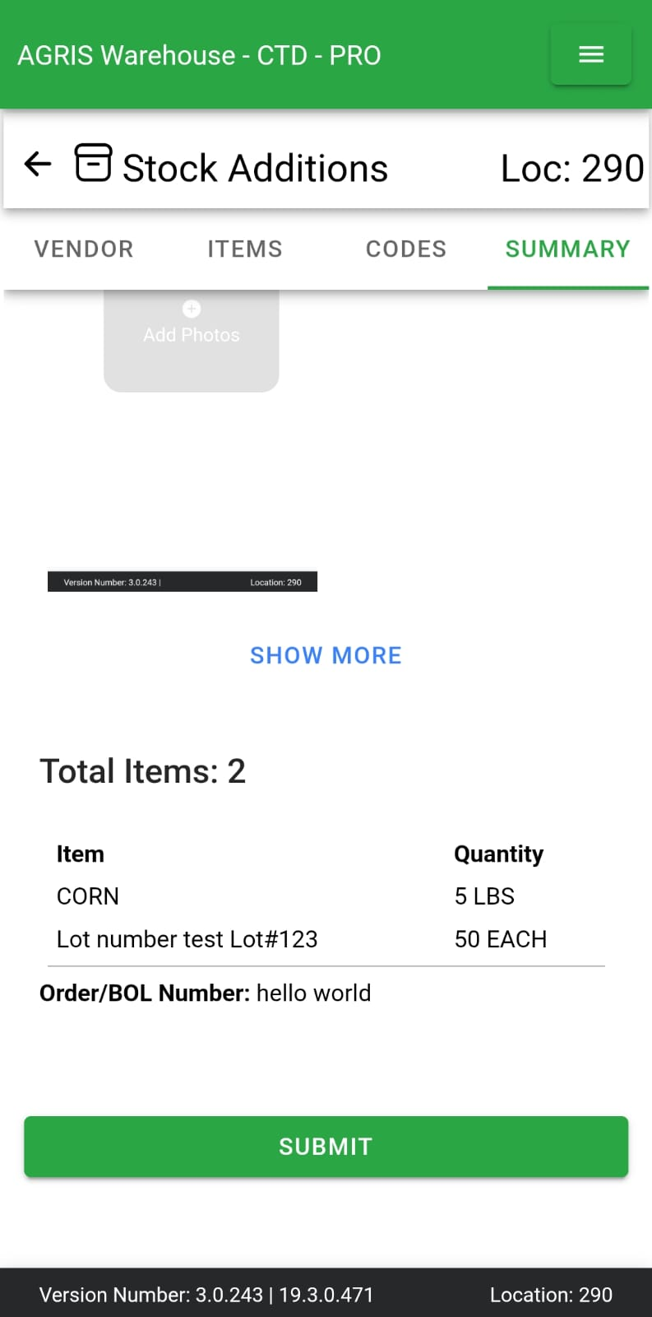

On submitting, we are taken to the completion screen with success message, email is asked to open to send the document.
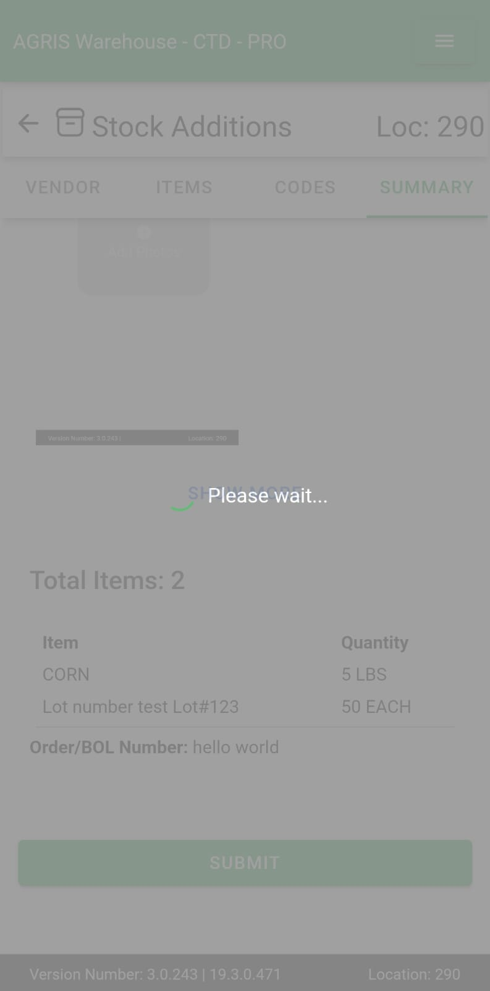
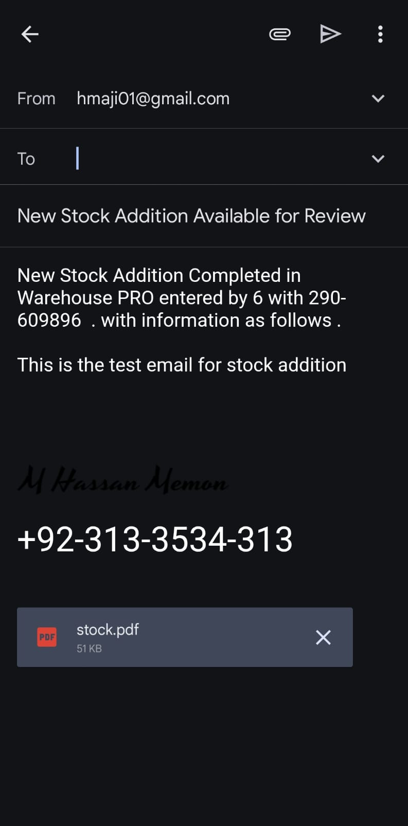
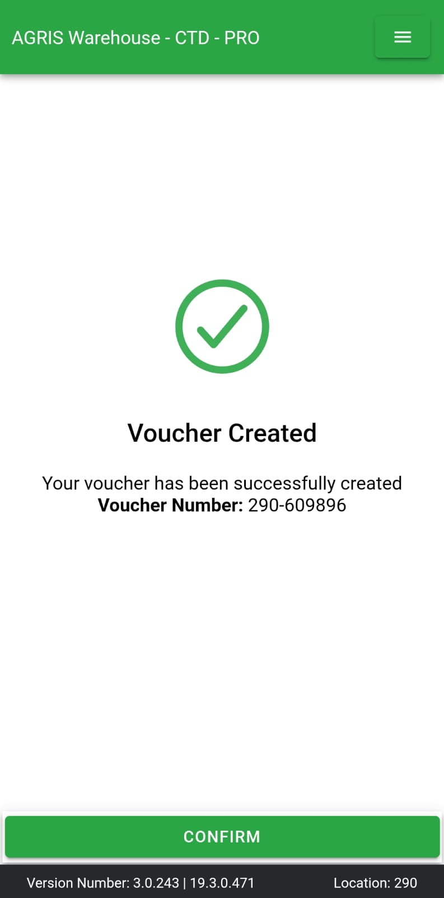
This created stockaddition can be viewed in the AGRIS as well, added images would be available in the path selected in the AL configuration.

